## tags table

## Fields

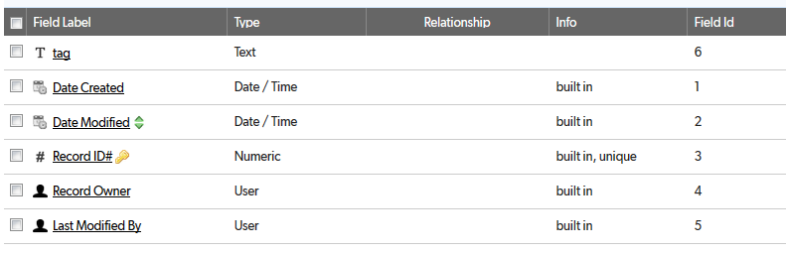

## Relationships

None

## Field settings

Note: Built-in fields use the default settings

tag 2

# tag

